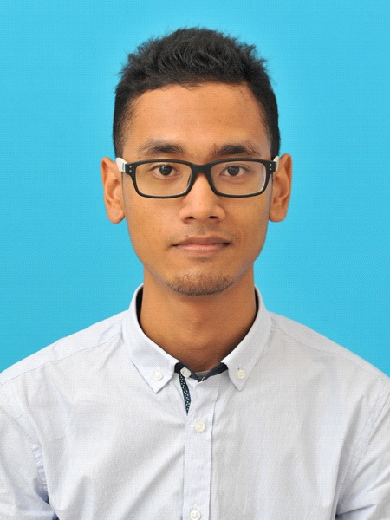

MUHAMMAD IZZAT AL-AMIN BIN MUSBAH
No.4A Lorong Kiri 8, Kampung Datuk Keramat,54000 Kuala Lumpur.
01131777267 jatkcube@gmail.com

OBJECTIVE & SUMMARY
To learn new things and constantly to improve myself for the benefits of the organization. Aim to build succesful career in any type of organization. Can cooperate and easy going person.

SKILLS
- Able to speak English and Bahasa Malaysia fluently (spoken and written)
- Good in communicating and persuading people, particularly prospective buyers
- Able to meet deadlines and work under bombardments of pressure
- Good in computer skills such as MS Words, MS Power Point, Ms Excel and Adobe Photoshop
EDUCATION
2009-2012
- Kolej Poly-Tech Mara Bangi, Seksyen 14, Jalan Teras Jernang, Bandar Baru Bangi, 43000 Kajang, Selangor
Diploma in Business Studies (UITM courses)
Final CGPA: 2.79

2004-2008
- PMR & SPM

EXTRA CURRICULAR ACTIVITIES
2010 - 2012
• 5th place in Nasyid Competition Festival Ramadhan JKKN
(Jabatan Kebudayaan Dan Kesenian Negara)
• Represented committee for Entrepreneurship Club to learn and study trip at Langkawi Island (KPTM Bangi)
• Participated for Sepak Takraw Competition in SUKOB 2011
• Participated for KPTM Bangi Hand Ball competition
• Insaniah Club Committee

WORK EXPERIENCE
3 Jan 2015 – 29 Feb 2016

1) Starting as administration clerk
Filing, manage bills, payment, runner, outbound and inbound call, dealing with exhibitors and client.

2) Get promoted to Assistance Project Manager
Manage invitation for university, schools and government agencies, handling stage activities or performances, work as runner on event, manage all item and equipment for upcoming expo, assist and handle project such as 'Ekspo Buku Mara 2015 & 2016', 'Ekspo Buku UIAM', 'Ekspo Buku MINDEF', manage store equipment, set-up and loading item for book expo.
-2015 history as event crew in Ekspo Buku Mara, Ekspo Buku Islam Putrajaya, Ekspo Buku MINDEF, Karnival Bidadari Masjid Tuanku Mizan Zainal Abidin, Ekspo Buku Masjid Negeri Shah Alam, Ekspo Buku UIAM.
-2016 history as event crew in Ekspo Buku Mara 2016 and Karnival Jelajah Ilmu IKIM Shah Alam.

28 Oct 2013 – 31 Dec 2014
- Editor at UBM Designs Sdn. Bhd for METADATA project in Arkib Negara Malaysia(MYCC).
-Conducting Quality Check on the description based on classified files in the Arkib Negara Malaysia prepared by team descriptors.

29 Jan 2013 -19 Mar 2013
- Customer Service Representative at VADS E-Services Sdn Bhd
-call inbound
-troubleshoot and solve the customer issues
-do technical support to customer

2012
- Marketing Officer at Tenaga S & A enterprise
-Handling finance and sale activities

2008- 2009
- Promoter at Parkson Kuala Lumpur City Centre and Sungei Wang Plaza

REFERENCES
UBM Designs Sdn. Bhd.
No.5.80/1, 5th Floor
Wisma Central, Jalan Ampang
50450, Kuala Lumpur, Malaysia
Tel no: 03-21611204
E-mail: admin@ubm.com.my

Nurhaziemah Binti Muhamad Zahari
Operation Manager
Sinergi Ilmu Resources Sdn Bhd
B-2B-24 Jalan 3/4C, Desa Melawati,
53100 Kuala Lumpur.
Office no: 0341058817
Tel no: 0137007067
E-mail: seminarsinergi@gmail.com

